01.

package com.mycompany.helloworld;

public class HelloWorld

{

public static void main(String[] args)

{

System.out.println("Hello World!");

}

}

02.

class Name_Digree

{

public static void main(String[] args)

{

System.out.println("Bamitha Ekanayake");

System.out.println("Computer Science");

}

}

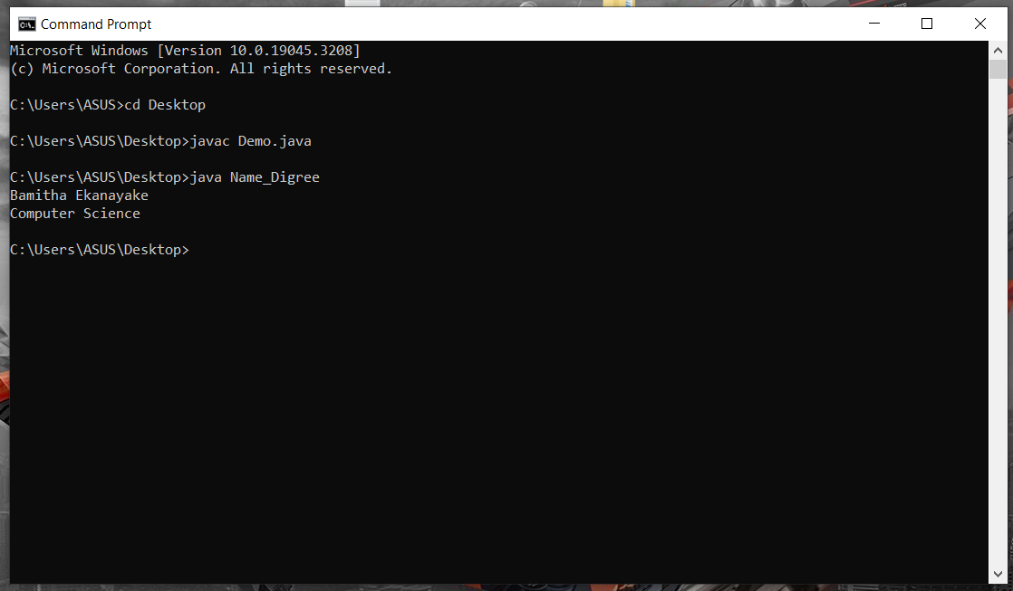

03.

package com.mycompany.helloworld;

public class HelloWorld

{

public static void main(String[] args)

{

for(int i=0;i<5;i++)

{

System.out.println("Executing Loop "+i);

}

System.out.print("\n");

int j=0;

while(j!=5)

{

System.out.println("Executing Loop "+j);

j++;

}

}

}

04.

//Break

10

20

I’m out of the Loop now.

//Continue

10

20

40

50

I’m out of the Loop now.

05.

i)

Excellent!

Your grade is A

ii)

Excellent!

You passed

Better Try Again

Your grade is A

iii)

package com.mycompany.helloworld;

public class HelloWorld

{

public static void main(String[] args)

{

char grade ='A';

if(grade=='A')

{

System.out.println("Excellent!");

}

else if(grade=='D')

{

System.out.println("You passed");

}

else if(grade=='F')

{

System.out.println("Better Try Again");

}

else

{

System.out.println("Invalid grade");

}

System.out.println("Your grade is "+grade);

}

}

06.

package com.mycompany.helloworld;

public class TestEnhanceForLoop

{

public static void main(String[] args)

{

int [] numbers = {10, 20, 30, 40, 50};

for(int x : numbers)

{

System.out.print(x);

System.out.print(",");

}

System.out.print("\n");

String [] names ={"James", "Larry", "Tom", "Lacy"};

for(String name : names)

{

System.out.print(name);

System.out.print(",");

}

}

}